PA CareerLink® Beaver County  job & career fair  October 24th  10:00AM to 2:00PM  Held inside the Beaver Valley Mall  (Planet Fitness/Rural King Corridor)  285 Beaver Valley Mall, Monaca, PA 15061  Phone: 724-728-4860 - www.pacareerlink.pa.gov  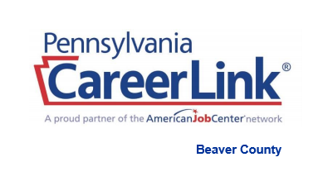  Check us out on Facebook - https://www.facebook.com/PA-CareerLink-Beaver-County | Bring Copies of Your Resume  ────  Dress for Success and Come Prepared to Market Your Skills  ────  Gain Information of High Demand Training Programs  ────  Meet and Interview with Employers  On-the Spot  ────  Learn about the emerging high demand jobs in the area  Sponsored by:  PA CareerLink Beaver County  Job Training for Beaver County  Beaver Valley Mall

