

Leave:

Beaver Falls Save-A-Lot

9:00 a.m.

Seneca Allegany Casino

12:00 – 5:00 p.m.

Return to Beaver Falls

Approx. 8:00 p.m.

**To reserve your seat, tickets can be purchased at the Cornerstone of Beaver County. Payment in full is needed to reserve a seat. All sales final. Should TCBC need to cancel trip, full refunds will be made. All proceeds support TCBC’s efforts to end homelessness in Beaver County.**

Fun while we travel on the motor coach!

50/50 & Raffles!

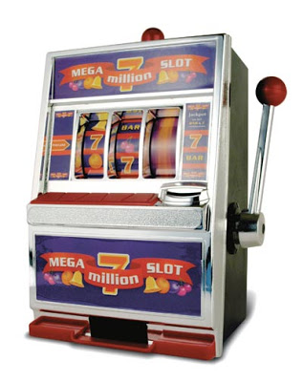

**Support TCBC!**

**Join us for a Casino Trip to Seneca Allegany Resort!**

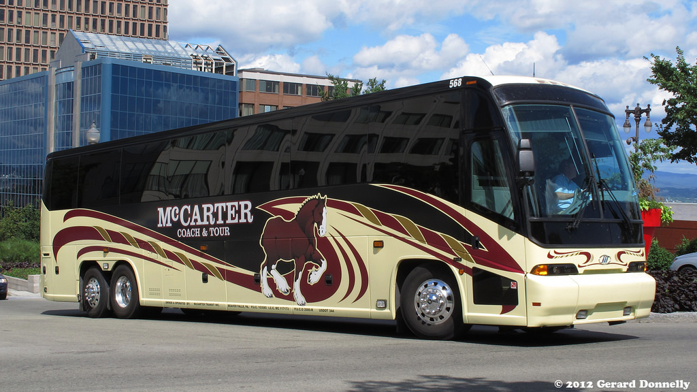

**April 27, 2019**

**$80 per person gets you:**

**Round trip deluxe transportation**

**$25 Free Slot Play**

**$5 Food Credit**

**FUN, FUN, FUN!**

